NEGATIVE ION Pestrepeller  TA-ER011 |  | ※※ INTRODUCTIONS ※  The Negative Ion Pest Repeller is the most outstanding unit among all EPC ( environment production cat ) product lines.  Pests will be repelled by the disturbance of noisy ULTRASONIC sounds emitted to them by this device.  It emits not only ultrasonic waves to repel rats, rodents, ants, cockroaches, spiders and other insects, but also creates a stream of beneficial negative ions which pull pollutants and backteria out of the air before entering human being’s and / or animal’s your lungs.  The emitting frequency range is far beyond the sound level that human beings and household animals can hear. It is absolutely safe, no harm to human beings and household animals.  - 2 - | ※※ FUNCTIONS ※※  - PEST REPELLER: It emits ultrasonic waves to repel not only rats, but also ants, cockroaches, spiders and other insects. The effective range is about 2,500 square feet.  - NEGATIVE ION GENERATOR: It generates negative ion gas to the air.  - Powered either by one 9V battery or AC power through an AC/DC power adaptor.  ※※ FEATURES ※※  - Portable: It is light and power can be supplied by one 9V battery, so that it can be used at anywhere such as room, cars, classrooms.  - Multifunctional: It is not only a pest repeller but also an ionic generator.  - Beautiful: The outward looking is  - 3 - | ※※ LOCATIONS OF CONTROL ※※  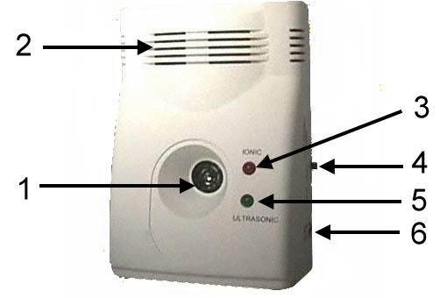  - ULTRASONIC WAVE OUTLET : The ultrasonic wave is emitted from this transducer.  - NEGATIVE ION GAS OUTLET : The negative ion gas is spreading out from this place.  - NEGATIVE ION indicator : The red LED lights up when negative ion gas is generating.  - FUNCTION SWITCH : 3 switchable modes --- OFF, ION, ULTRASONIC.  - ULTRASONIC indicator : The green LED lights up when ultrasonic wave is emitting.  - POWER IN JACK : The power is supplied by plug in an AC/DC power adaptor.  - 4 -
ROOM PEST REPELLER WITH NEGATIVE ION GENERATOR
OPERATION MANUAL
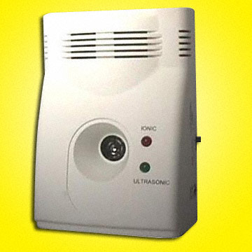
※※ APPLICATIONS ※※  - Bedrooms, living rooms, Computer rooms.  - Hospitals, clinics, sickrooms.  - Shops, stores.  - Restaurants.  - Ships, boats.  - Drug stores.  - Classrooms.  - Grocery stores.  - Bookshops.    - 5 - |  | ※※ INSTALLATIONS ※※  USE AT ROOMS  - Place or hang it at height between 25 – 60cm above the ground since the ultrasonic wave spreads out at an wide angle of 80 degree.  - To get the best performance, we strongly suggest you to place and fix it towards or between walls, steel flat boards. This is the purpose to let ultrasonic waves reflect repeatedly between above obstacles.  - Take out AC/DC power adaptor from gift box; Make sure that the input power voltage fits the power source ( generally it is from wall power outlet ). Then plug it into the power outlet and the unit.  USE AT CAR  - Place it at the back of rear seat or the side of meter window.  - Take out the DC power cord from gift box and plug into car’s DC outlet jack.  - 6 - | ※※ OPERATIONS ※※  - According to your requirement to push the function switch. Push it at “IONIC” position, the unit will generate ionic gas; Push to “ULTRASONIC’ position, the unit will generate ultrasonic wave.  - Red LED will be flashing when NEGATIVE ION generating function is activated; GREEN LED light will be flashing when ULTRASONIC wave is emitted.  ※※ SPECIFICATIONS ※※  - INPUT POWER: 12V, 500mA.  - OUTPUT POWER: 3W ( 110dB)  - FREQUENCIES: 20 – 32kHz.  - EFFECTIVE COVERAGE: about 5000 square feet in open area, 1800 square feet in closed area.  - DIMENSION: 7.8cm(width ) x 11.6cm(height) x 5.1cm(depth).  - WEIGHT: 300 grams.  - 7 - | ※※ CAUTIONS ※※  - The ultrasonic sound might cause unpleasant feeling to specific persons. Try to change the frequency and remove it away from his ear.  - The repeller is useful for most of mouses, moles, rates, insects and some cockroaches. But it is possible to face no reactions from above pests when they have deaf disease or they are really very hungry, thirsty. They might hide at the back of wall, steel board, refrigerator, microwave oven...etc, so that the repeller’s ultrasonic wave cannot influence them.  - The ultrasonic sound is no harm to human beings and pets, domestic animals. But do not put it closed to baby or infant since their ear is weak.  TRONIC ACE TECHNOLOGY INC.  TEL: (886 2)22671180  FAX: (886 2)29122889  http://www.unitone.com.tw  E-MAIL: sales@unitone.com.tw

