pro Pestrepeller  TA-ER315 |  | ※※ FEATURES ※※  - ELIMINATES MOST PESTS AWAY --- It changes the frequency of emitting waves 1 - 60 times in a second automatically to assure the complete coverage of almost communication frequencies of rodents insects and many other pests. And make them not get used to the ultrasonic waves.  - SANITARY AND SAFE --- It eliminates pests by generating ultrasonic waves. More sanitary and economical than chemical poison method. It is no harm to human beings and any other animals. It’s also no pollution to environment.  - HIGH EFFICIENCY, WIDE RANGE PERFORMANCE ---The high power emitting of ultrasonic waves drive pests away for wide range ( 3 – 6 meters in diameter ).  - NO INTERFERENCE TO ELECTRIC APPLIANCES --- It will not interfere with any electric/electronic appliance such as home/car burglar alarm, fire or smoke detector, radio, television reception, microwave oven, electro-magnetic oven, computer, cordless phone or | cellular phone.  - THE MORE LONGER YOU USE, THE MORE EFFECTIVE IT IS --- The obvious effects appear in 2 – 4 weeks after the installation. The continuous use will prevent further nesting and inhabitations.  ※※FUNCTIONS ※※  - Manually adjustable ultrasonic frequency range from 20kHz to 32kHz.  - Adjustable strength of output sound level.  - It repels not only rats but also most of pests such as fleas, beetles, ticks, spiders, silverfish, crickets, roaches, black flies, ants, moths, waterbugs, mice and mites.  - Durable steel aluminum housings with black coating.  - The effective range is about 5,000 square feet.  - 3 - | ※※ LOCATIONS OF CONTROL ※※  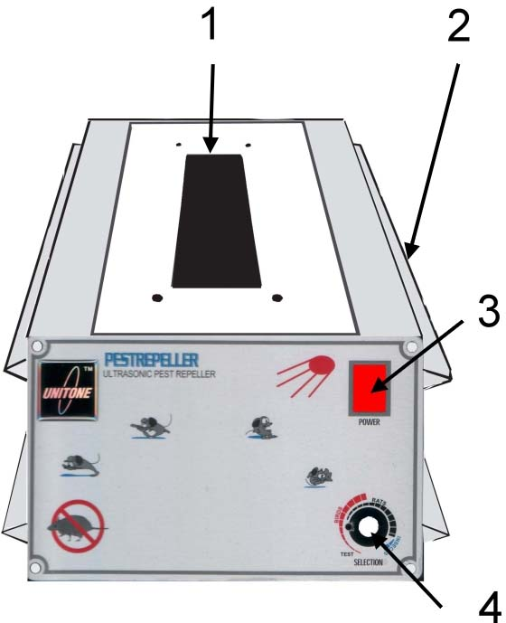  - BUZZER : When the power is turned on, ultrasonic wave will be generated from here.  - POWER IN JACK : The power is supplied by plug in an AC/DC power adaptor.  - POWER SWITCH ( red ) : Press the top can turn on the power. The switch will light on when you power it on.  - 4 -
ULTRASONIC PEST REPELLER
OPERATION MANUAL
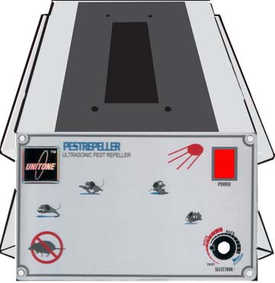
- FREQUENCY SELECTION KNOB : turn it in clockwise direction can increase the output ultrasonic wave frequency from 20kHz to 32kHz.  ※※ INSTALLATIONS ※※  - Place or hang it at height between 25 – 60cm above the ground since the ultrasonic wave spreads out at an wide angle of 130 degree.  - To get the best performance, we strongly suggest you to place and fix it towards or between walls, steel flat boards. This is the purpose to let ultrasonic waves reflect repeatedly between above obstacles.  - Take out AC/DC power adaptor from inner box; Make sure that the input power voltage fits the power source ( generally it is from wall power outlet ). Then plug it into the power outlet and the unit.  - 5 - |  | ※※ APPLICATIONS ※※  - Homes especially at kitchens.  - Computer rooms.  - Hospitals, clinics.  - Shops, stores.  - Restaurants.  - Ships, boats.  - Drug stores.  - Supermarkets.  - Grocery stores.  - Food processing firms.  - Food warehouses.  - Farms.  - Warehouses. 14. Book shops.  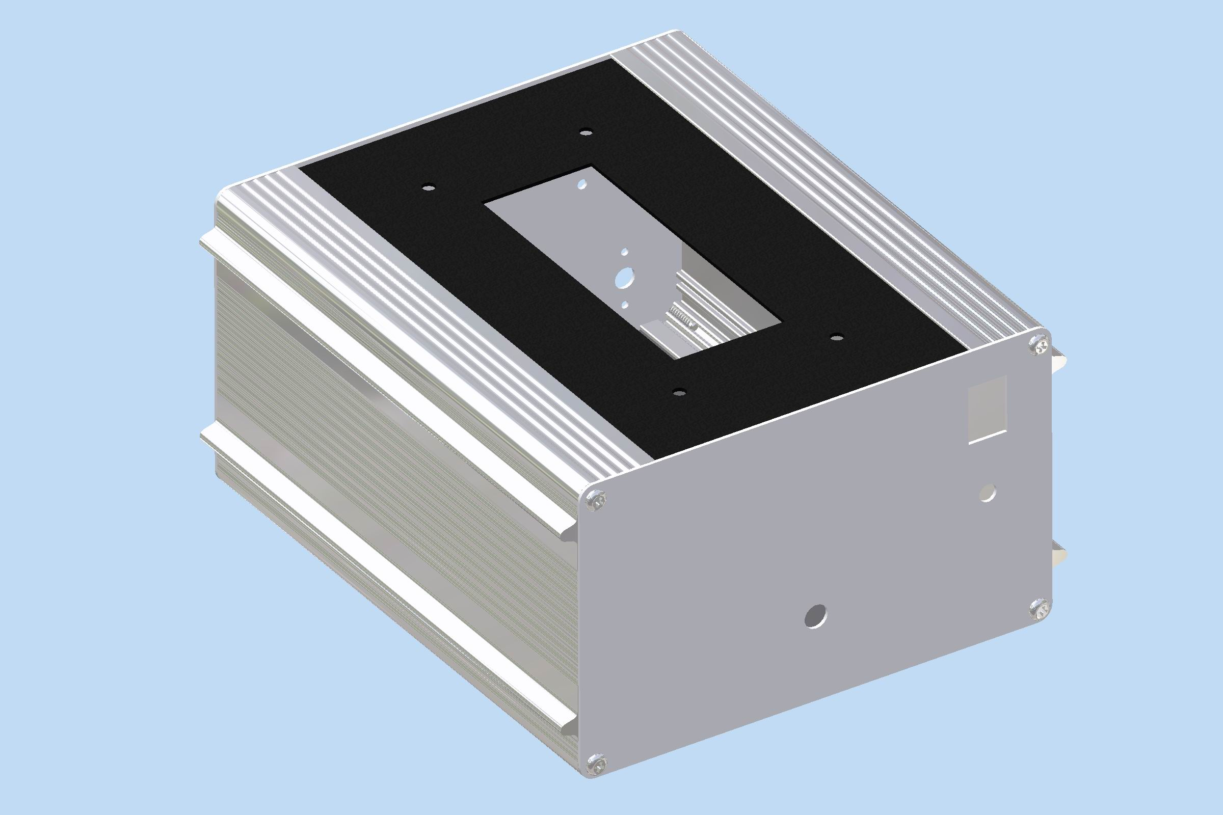  - 6 - | ※※ OPERATIONS ※※  - Turn on the power, the switch will light on.  - According to your requirement to adjust the sound frequency selection knob.  - You will hear irregular ‘PIG-PAG” sound from the machine. It is the ultrasonic sound that is harmless to human beings and domestic fowls and livestock.  ※※ SPECIFICATIONS ※※  - INPUT POWER: 12V, 500mA.  - OUTPUT POWER: 3W ( 110dB)  - FREQUENCIES: 20 – 32kHz.  - EFFECTIVE COVERAGE: about 5000 square feet in open area, 1800 square feet in closed area.  - DIMENSION: 17.4cm(width ) x 10cm(height) x 21.3cm(depth).  - WEIGHT: 980 grams.  - 7 - | ※※ CAUTIONS ※※  - The ultrasonic sound might cause unpleasant feeling to specific persons. Try to change the frequency and remove it away from his ear.  - The repeller is useful for most of mouses, moles, rates, insects and some cockroaches. But it is possible to face no reactions from above pests when they have deaf disease or they are really very hungry, thirsty. They might hide at the back of wall, steel board, refrigerator, microwave oven...etc, so that the repeller’s ultrasonic wave cannot influence them.  - The ultrasonic sound is no harm to human beings and pets, domestic animals. But do not put it closed to baby or infant since their ear is weak.  TRONIC ACE TECHNOLOGY INC.  TEL: (886 2)22671180  FAX: (886 2)29122889  http://www.unitone.com.tw  E-MAIL: sales@unitone.com.tw

