Televoicer | ※※ USAGES ※※  For stationary phones, cellular phones, speaker phones, walkie talkies, door phones … etc.  ※※ SITUATIONS ※※  - SINGLE FEMALE -- words off unwanted villains.  - HOME ALONE CHILDREN – words off villains.  - CALL SCREEN – Bypasses answering undesired phone calls, reduces harassment calls.  - ONE-MAN COMPANY – makes other think there are many employees.  - WIVES – spy on hushands.  - PEOPLE – entertains friends and family member.s.  ＜ 2 ＞ | ※※ LOCATIONS ※※  - VOLUME with POWER ON/OFF.  - MIC: speech input piece.  - LED: power indicator ( faded red means low battery; no light means no battery ).  - PITCH ADJUSTER: 8 selections – 3 high pitches, 3 low pitches, 1 normal sound, 1 robot sound.  - SOUND INSULATOR: used to block out noise interference.  - SPEAKER: voice output piece ( fits over phone mouth piece ).  - BATTERY COVER.  ＜ 3 ＞ | 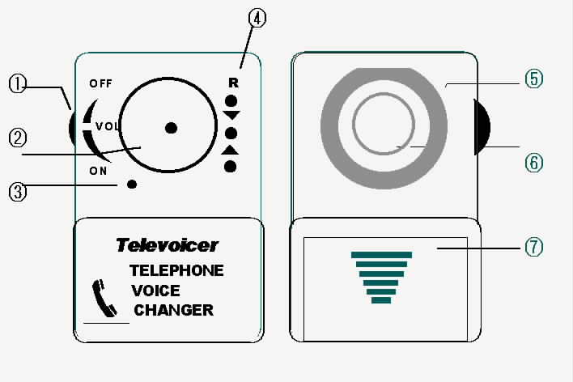  ＜ 4 ＞
  
  OPERATION MANUAL
  TELEPHONE VOICE CHANGER
  LG-206A
  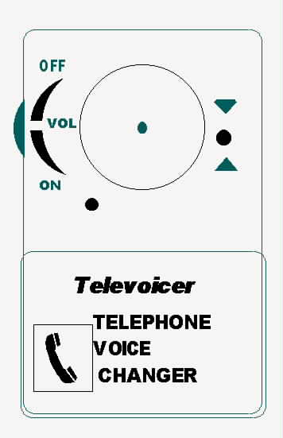
R: ET, robot-like sound.  ▼: lower trend pitch.  ▲: higher trend pitch.  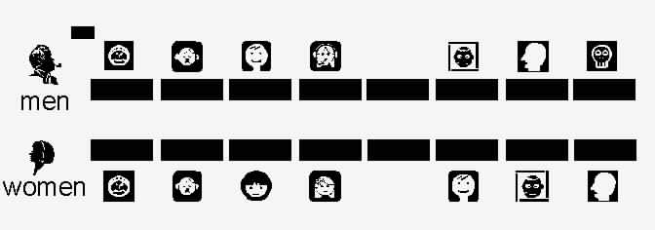  ＜ 5 ＞ | ※※ OPERATIONS ※※  - Put device over the telephone mouthpiece ( handset ). Make sure that sound insulator surrounds the mouth piece.  - Turn on volume and adjust ( change to male – high volume; to female – low volume; ET – lowest volume ).  - Select desired pitch ( use the telephone receiver to hear the selection and make changes to satisfaction ).  - Speak into sound input ( avoid frequently used speak structure ). For the best result, fake the voice ).  ＜ 6 ＞ | - When using ET, speak slowly and distinctively. Avoid dragging or linking sounds.  ※※ CAUTIONS ※※  - If voice changing fails, please check the followings:  〈a〉Telephone is steadily placed.  〈b〉If the mouth piece has an irregularshape or if the sound insulator fits over it.  〈c〉Review the instruction.  〈d〉Battery power is full and is inserted.  〈e〉Check voice clarity.  ＜ 7 ＞ | - Keep device dry; Do not expose to direct sun or open flame.  - Do not smash device.  - Do not use this device for unlawful purpose ( i.e. harassing or vengeful conduct ).  TRONIC ACE TECHNOLOGY INC.  11th. Floor, No.3 Lane 116, Section 3, Chungyang Road, Tucheng City, Taipei 236, Taiwan.  TEL:(886 2)22671180, 22685278  URL: http://www.unitone.com.tw  E-MAIL: tronic@seed.net.tw  ＜ 8 ＞

