Pocket Bugtracer  TA-PM101 |  | ※※ FEATURES ※※  - Wide Range Detection： Ranged from 1MHz to 3GHz（3000MHz）.  - Adjustable Sensitivity Selections：For various situations and applications.  - Mini, pocket size：Small size makes it easily portable.  ※※ SITUATIONS ※※  - Detecting wireless hidden camera.  - Detecting wireless bugging devices such as UHF ( or VHF/ FM ) telephone message transmitter, UHF ( or VHF/ FM) room message transmitter.  - Detecting microwave. | ※※LOCATIONS ※※  - Extendible Rod Antenna ( 5 sections ).  - Power Indicator ( LED ).  - High Sensitivity Push Button. (A).  - Low Sensitivity Push Button. (B).  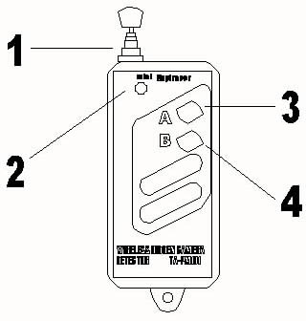 | ※※ OPERATIONS ※※  - Pull up extendible antenna.  - Locate the Area: Hold the unit and press “A” button ( high sensitivity ) and move smoothly across the target area. If a signal is detected the unit will “BEEB” continuously and steadily. The closer the signal is the louder the beep becomes. Then,  - Find Out the Transmitter: Press the “B” button ( low sensitivity ) and move smoothly across the target area. The detector will shorten the signal area.  - Screening radio waves：There are many radio signals in the air at all times. You should screen and remove any excess signals coming from cordless phones, pagers, cellular phones walkie talkies, wireless door chimes, remote controllers. Following lists are references to your detection.
Wireless Hidden Camera Detector
OPERATION MANUAL
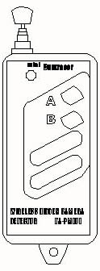
※※ IMPORTANT TO YOUR DETECTION ※※  - A wireless hidden camera can be detected from 18 inches away since its’ a high power output.  - If the beep sound is not continuous and not steady, the radio wave may be coming from a cellular phone or PHS.  - If the beep sound appears suddenly and disappears then, the radio waves may be coming from the cordless phone or door chime, car remote controlling unit. |  | ※※ SPECIFICATIONS ※※  - Detection Range: - 1MHz~3GHz.  - Weight - 130g（battery included ）.  - Dimension - 110mm x 71mm x 24mm（ antenna excluded ）.  - Housing – ABS plastic case with wooden coating.  - Power – use a “A23” (12V) batteries. | ※※ CAUTIONS ※※  - To get good performance, please do not use wireless electronic appliances such as cordless phones, radio transceivers, cellular phones, remote controllers, microwave oven, television set and cellular phone jammers whenever you are executing the radio search; Since they will all generate radio signals.  - The detector detects radio signals sent from wireless camera, cellular phone, PHS phone and any type of wireless bugging device. It cannot detect the wired camera, or microphone that does not send out radio signal.  - The detector also cannot be proved to detect radio signals that is beyond 3GHz ( 3000MHz ) or under 1MHz.  - The wireless hidden camera transmitting frequencies are at around 900MHz, 1200MHz and 2400MHz and the transmitting output power are higher than 50mW (0.05W) in general. So that the detector can detect almost all wireless hidden cameras easily. | - Do not put too many objects together with the detector at your pocket. This is to prevent from unwilling touch at push button(s).  - The detector does not generate any radio signal, so that it is no harm to human beings and animals.  - Remember to check the battery before operation. Replace the battery when you see the faded LED light.  - To replace the battery, please loosen screws at the rear cabinet.  TRONIC ACE TECHNOLOGY INC.  TEL: (886 2)22671180  FAX: (886 2)29122889  URL: http://www.unitone.com.tw  E-MAIL: tronic@seed.net.tw

