Tele-adjuster | ※※ USAGES ※※  For stationary phones, office telephone extension phones, and door phones… etc.  ※※ APPLICATIONS ※※  - Hearing impaired people for telephone conversations.  - Hearing aid for old men in telephone conversations who is weak of hearing.  - Hearing air for telephone conversations in noisy environment.  - Hearing-aid for office telephone system that the extension phone volume level is weak because of the telephone switching system.  ＜ 2 ＞ | ※※ LOCATIONS ※※  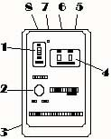  ＜3＞ | 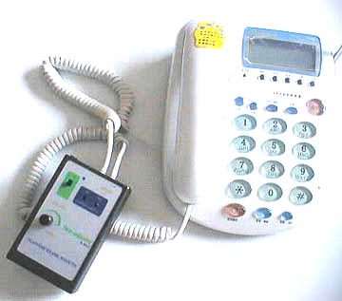  ＜ 4 ＞
  
  TELEPHONE INCOMING VOLUME
  ADJUSTER TA-TA313
  OPERATION MANUAL
  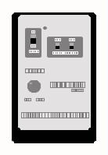
  1. POWER ON/OFF SWITCH
  2. INCOMING VOLUME CONTROLLING KNOB
  3. BATTERY COVER
  4. HANDSET WIRING SWITCHES（to fit various kinds of handset wiring designs from various telephone models ）
  .5. PHONE JACK (for connecting unit to telephone handset.
  6. PHONE JACK (for connecting unit to telephone body. .
  7. POWER JACK
※※ INSTALLATIONS ※※  - Take out battery compartment cover and insert a 9V battery. Then cover it to the unit.  - Loose the Telephone Coiled Cord from your telephone handset and insert it to the unit’s PHONE JACK ( 6 ) that marked “BODY”.  - Take out Handset Coiled Cord and insert one end to the unit’s PHONE JACK ( 5 ) that marked “HANDSET” and the other end to the telephone handset. ＜ 5 ＞ | - Turn on the POWER by pushing the “POWER ON/OFF SWITCH” to "ON position.  - Pick up the telephone handset to check whether you hear the telephone sound or not.  - If you cannot hear the sound, push the SW! and SW2 at “HANDSET WIRING SWITCH” to “up’’ position simultaneously.  - If you still cannot hear the sound, it might means that your telephone handset wiring is special. Ask for wiring modification service from your vender. | ※※ OPERATIONS ※※  - The Tele-adjuster can either increase or decrease the incoming sound level through telephone conversation.  - To use the device while you are talking with the other party through the telephone, switch on the power by pushing “ POWER ON/OFF SWITCH” to “ON” position. See if the “POWER INDICATOR” lights up.  - Adjust the “VOLUME ADJUSTMENT KNOB” to obtain preferable sound level.  ＜ 7 ＞ | ※※ CAUTIONS ※※  - Since the telephone handset wiring ( 2 microphone cords and 2 speaker cords ) is not strictly stipulated, there are various kinds of wiring combinations at each telephone set. If you are the man that unfortunately encounter this problem, you can either change the wiring yourself or ask your vendor for the service. You are also recommended to change iit to a common, popular telephone set in the market.  TRONIC ACE TECHNOLOGY INC.  http://www.unitone.com.tw  ＜ 8 ＞

